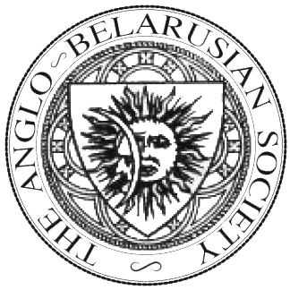

THE ANGLO-BELARUSIAN SOCIETY

Membership Application Form

Please use Block Capitals

Name _______________________________________________________________________________

Organisation (if applicable) _______________________________________________________________________________

Position (if applicable)__________________________________________________________________

Address________________________________________________________________________

_______________________________________________________________________________

Tel. ______________________________________ E-mail _______________________________

Special areas of interest in Belarus _______________________________________________________________________________

I wish to apply for Membership of the Anglo-Belarusian Society and support its broad aims and principles. I agree to abide by the Society’s By-Laws.

Signed ________________________________________ Date _____________________________

Please tick the relevant box below and return this form wither by email (mail@absociety.org.uk) or by post to Yaraslau Kryvoi, Anglo-Belarusian Society, Flat 4, 52 Penn Road, London, N7 9RE. Please make a subscription payment using one of the methods described below. The subscription year runs from one Annual General Meeting (usually held in January) to the next.

 Annual subscription for UK and overseas - £20

for Council use:

Membership approved by Council on ____________________ Signed (Secretary) _______________________

-----------------------------------------------------------------------------------------------------------------------------------------------
The objects of the Society shall be:
(a) The diffusion, interchange and publication of knowledge relating to Belarus, its people and its culture;
(b) The raising, receiving and holding of monies, properties and assets for the above-mentioned object;
(c) The promotion of all other lawful activities as may be conducive or incidental to the attaining of the above-mentioned objects as shall from time to time be directed by Council.
(Article 2 of the By-Laws of the Anglo-Belarusian Society)

You can pay using Donate button at http://absociety.org.uk

